1. Connect to the Store Sales Data and do the following: -

− Remove all the blank rows.

− Update the column header if they are not updated

– Create a text table and show the sales in terms of : Customers , Product Category , Regions

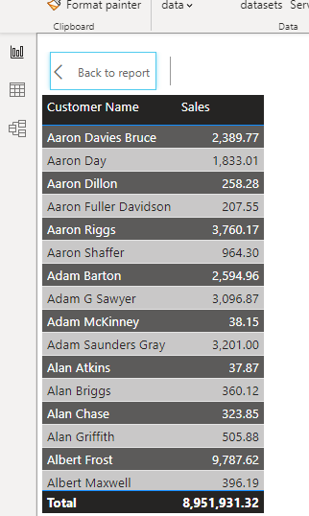

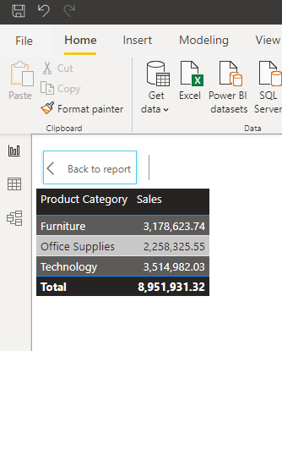

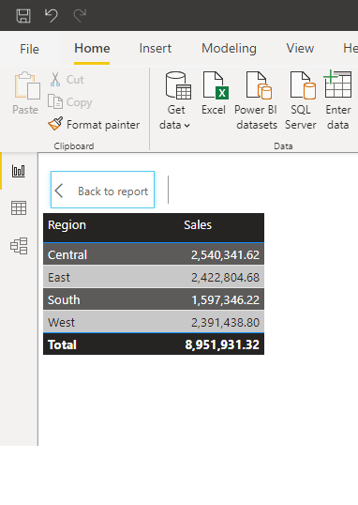

2.Create a line and Clustered Column Chart showing the Sales and Discount as per the State or Province

− Format the bars and line with different colors − Which state has the highest sales in terms Technology

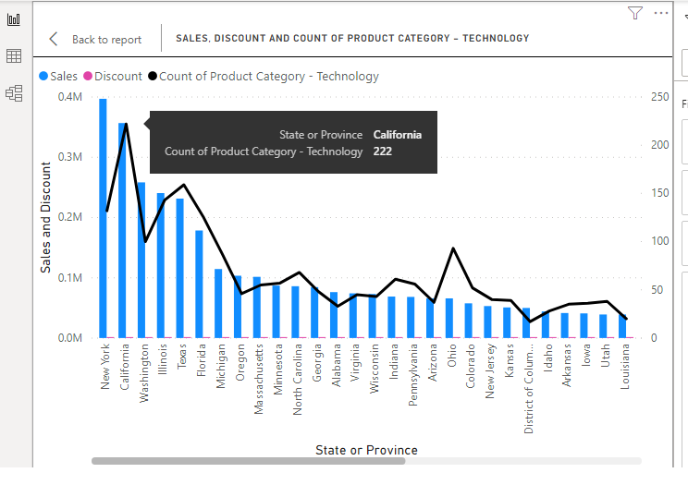

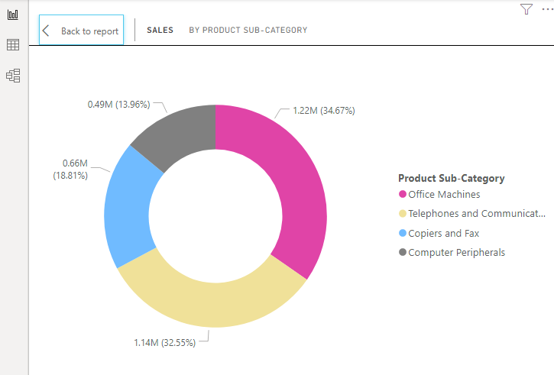3. Create a Donut Chart showing sales in terms of Product category

4.Create a Slicer and show the regions in dropdown. See how all the visuals mentioned above behaving when a particular region is selected.

